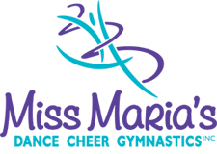

Miss Maria’s Referral Fundraising

Upon completion of a New Patient Chiropractic Adjustment, Baltuska Chiropractic will donate $20 toward this competitor’s trip to the national competition:

Name:___________________________________________ Date:__________________

Baltuska Chiropractic
13830 Santa Fe Trail Drive Suite 102 Lenexa KS 66215
913-283-9803 www.baltuska.com
KellyBaltuska@gmail.com

